Division Info Batch Feed Configuration Document

Database Changes

New Columns are added to YFS_ORGANIZATION and 2 hangoff tables are created for the same tables. Please find attached the XPX_YFS_ORGANIZATION_EXTN.xml
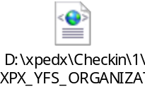

Service Configuration Done
Go to Application Platform->Process Modeling->General->General->Services->Create new service (XpedxDivisionInfoLoad)

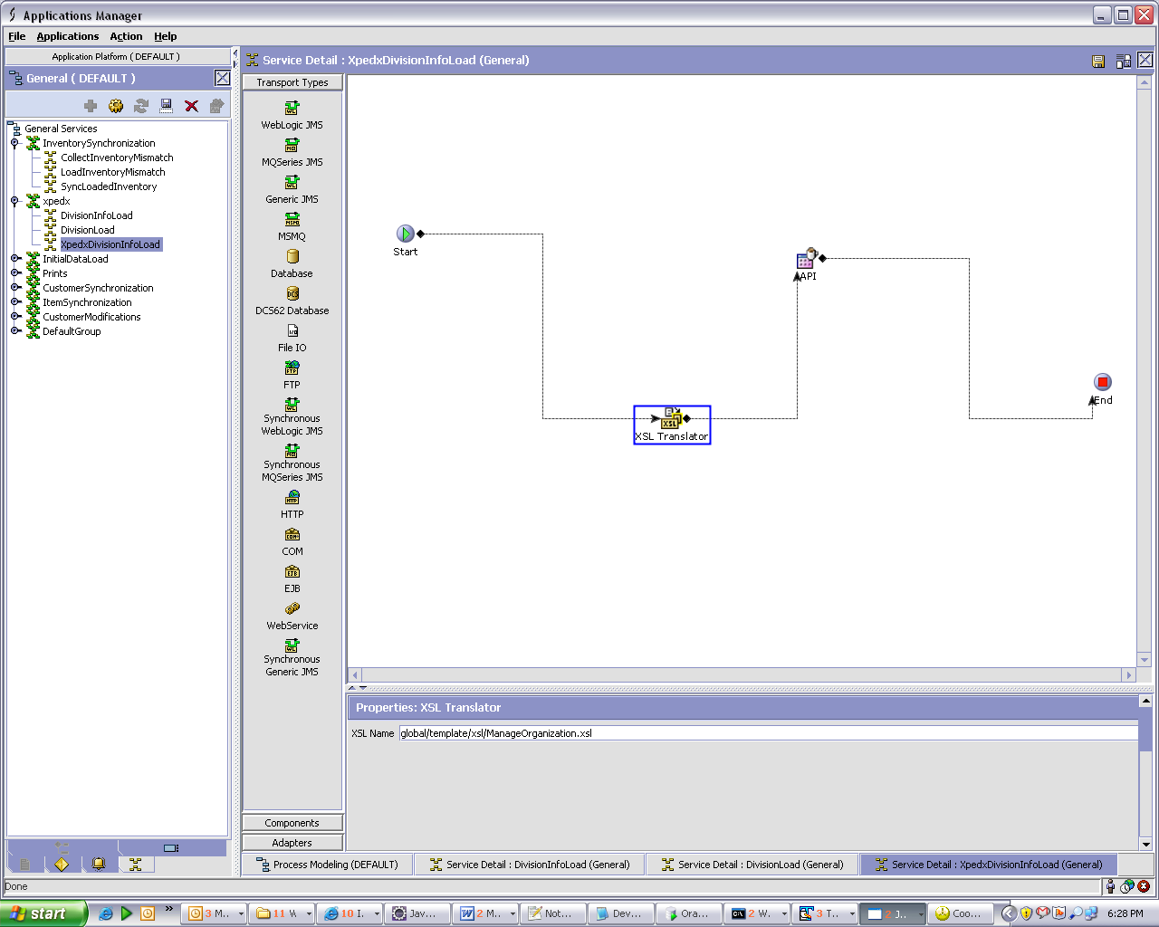

XSL Name=global/template/xsl/XPX_Manage_Organization.xsl
API Name=manageOrganizationHierarchy ()

Find attached the XSL used it has to be saved in “<INSTALL-DIR>\extensions\global\template\xsl “folder.
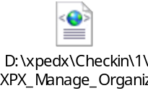

Input Received from Web Method.

<?xml version=”1.0” encoding=”utf-8”?>
<Divisions>
<Division EnvironmentId =”” CompanyCode =”’ DivisionNumber=”” ProcessCode=”” DivisionName=”” Address1=”” Address2=”” Address3=”” City=”” State=”” ZipCode=”” CountryCode=”” DivisionPhone=”” DivisionFax=”” CurrencyCode=”” PricingWarehouse=”” Geocode=”” JDECode=”” eTradingID=”” BrandCode=”” >
<TransferCircles>
<TransferCircle DivisionNumber=”” DivisionName=”” NoOfDays=”” OrderCutOffTime=”” />
</TransferCircles>
</Division>
</Divisions>

Format of InputXML for manageOrganizationHierachy () API to insert records to YFS_ORGANIZATION and 2 hang off tables is.

<Organization Operation="Create" OrganizationCode="XpdxNode0104" OrganizationName="XpdxNode0104" PrimaryEnterpriseKey="Xpedx" >

<ContactPersonInfo AddressLine1="" AddressLine2="" AddressLine3="" City="" Country="US" DayFaxNo="" DayPhone="" Department="" EMailID="" ErrorTxt="" EveningFaxNo="" EveningPhone="" FirstName="" HttpUrl="" JobTitle="" LastName="" Latitude="" Longitude="" MiddleName="" MobilePhone="" OtherPhone="" PersonID="" PreferredShipAddress="" State="" Suffix="" Title="" UseCount="" VerificationStatus="" ZipCode="" />
<CorporatePersonInfo AddressID="" AddressLine1="" AddressLine2="" AddressLine3="" AddressLine4="" AddressLine5="" AddressLine6="" AlternateEmailID="" Beeper="" City="" Company="" Country="US" DayFaxNo="" DayPhone="" Department="" EMailID="" ErrorTxt="" EveningFaxNo="" EveningPhone="" FirstName="" HttpUrl="" JobTitle="" LastName="" Latitude="" Longitude="" MiddleName="" MobilePhone="" OtherPhone="" PersonID="" PreferredShipAddress="" State="" Suffix="" Title="" UseCount="" VerificationStatus="" ZipCode="" />
<BillingPersonInfo AddressID="" AddressLine1="" AddressLine2="" AddressLine3="" AddressLine4="" AddressLine5="" AddressLine6="" AlternateEmailID="" Beeper="" City="" Company="" Country="US" DayFaxNo="" DayPhone="" Department="" EMailID="" ErrorTxt="" EveningFaxNo="" EveningPhone="" FirstName="" HttpUrl="" JobTitle="" LastName="" Latitude="" Longitude="" MiddleName="" MobilePhone="" OtherPhone="" PersonID="" PreferredShipAddress="" State="" Suffix="" Title="" UseCount="" VerificationStatus="" ZipCode="" />
<Node NodeType="Store" />

<Extn ExtnPriceWarehouse="DELL" ExtnGeoCode="pqrs" ExtnJdeCode="fghdf" ExtnEtradingID="fghdf" ExtnBrandCode="SP" ExtnCurrencyCode="USD" >
<XPXDivBrandList>
<XPXDivBrand BrandCode="BD"
DivisionNo="XpdxNode10" />
</XPXDivBrandList>

<XPXXferCircleList>
<XPXXferCircle DivisionName="XpdxNode10" DivisionNo="XpdxNode10" NoOfDays="5" SourceDivision="XpdxNode8" SequenceNo="1" />
</XPXXferCircleList>
</Extn>
</Organization>

Appendix : Xpedx Batch Feeds-Division Info Batch Feed Detailed Design V1.1

